**TRƯỜNG ĐẠI HỌC SƯ PHẠM KỸ THUẬT**

**KHOA CÔNG NGHỆ SỐ**

**🙠🕮🙢**



**BÀI TẬP MÔN**

**LẬP TRÌNH TRÊN ĐTDĐ**

**ÔN TẬP JAVA**

**Họ và tên:** Nguyễn Triều Tiên

**MSSV:** 23115053122336

**Lớp học phần:** 125LTTD02

*Đà Nẵng, tháng 09 năm 2025*

**MỤC LỤC**

**I)** **Bài 1** 1

1) Link GitHub 1

2) Code 1

a) Lớp PhanSo 1

b) Lớp TestClass 3

3) Kết quả 4

**II)** **Bài 2** 5

1) Link GitHub 5

2) Code 5

a) Lớp CanBo 5

b) Lớp NhanVien 6

c) Lớp CongNhan 6

d) Lớp KySu 7

e) Lớp QLCB 7

f) Lớp TestClass 8

3) Kết quả 9

**III)** **Bài 3** 10

1) Link GitHub 10

2) Code 10

a) Lớp TaiLieu 10

b) Lớp Sach 11

c) Lớp Bao 11

d) Lớp TapChi 12

e) Lớp TestClass 12

3) Kết quả 13

**IV)** **Bài 4** 14

1) Link GitHub 14

2) Code 14

a) Lớp ThiSinh 14

b) Lớp KhoiA 15

c) Lớp KhoiB 15

d) Lớp KhoiC 15

e) Lớp TuyenSinh 16

f) Lớp TestClass 17

3) Kết quả 17

**V)** **Bài 5** 19

1) Link GitHub 19

2) Code 19

a) Lớp Nguoi 19

b) Lớp HoDan 20

c) Lớp KhuPho 21

d) Lớp TestClass 22

3) Kết quả 23

**VI)** **Bài 6** 24

1) Link GitHub 24

2) Code 24

a) Lớp Nguoi 24

b) Lớp KhachTro 25

c) Lớp KhachSan 26

d) Lớp TestClass 27

3) Kết quả 27

**VII)** **Bài 7** 28

1) Link GitHub 28

2) Code 28

a) Lớp Nguoi 28

b) Lớp HocSinh 29

c) Lớp QLHS 30

d) Lớp TestClass 31

3) Kết quả 31

**VIII)** **Bài 8** 32

1) Link GitHub 32

2) Code 32

a) Lớp Nguoi 32

b) Lớp CBGV 33

c) Lớp QuanLy 34

d) Lớp TestClass 34

3) Kết quả 35

**IX)** **Bài 9** 36

1) Link GitHub 36

2) Code 36

a) Lớp SinhVien 36

b) Lớp TheMuon 37

c) Lớp QuanLy 38

d) Lớp TestClass 38

3) Kết quả 39

**X)** **Bài 10** 39

1) Link GitHub 39

2) Code 39

3) Kết quả 39

# **Bài 1**

## Link GitHub

## Code

### Lớp PhanSo

### Lớp TestClass

## Kết quả

# **Bài 2**

## Link GitHub

## Code

### Lớp CanBo

### Lớp NhanVien

### Lớp CongNhan

### Lớp KySu

### Lớp QLCB

### Lớp TestClass

## Kết quả

# **Bài 3**

## Link GitHub

## Code

### Lớp TaiLieu

### Lớp Sach

### Lớp Bao

### Lớp TapChi

### Lớp TestClass

## Kết quả

# **Bài 4**

## Link GitHub

## Code

### Lớp ThiSinh

### Lớp KhoiA

### Lớp KhoiB

### Lớp KhoiC

### Lớp TuyenSinh

### Lớp TestClass

## Kết quả

# **Bài 5**

## Link GitHub

## Code

### Lớp Nguoi

### Lớp HoDan

### Lớp KhuPho

### Lớp TestClass

## Kết quả

# **Bài 6**

## Link GitHub

## Code

### Lớp Nguoi

### Lớp KhachTro

### Lớp KhachSan

### Lớp TestClass

## Kết quả

# **Bài 7**

## Link GitHub

## Code

### Lớp Nguoi

### Lớp HocSinh

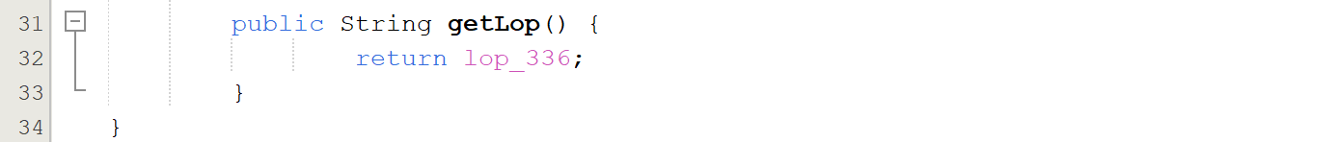

### Lớp QLHS

### Lớp TestClass

## Kết quả

# **Bài 8**

## Link GitHub

## Code

### Lớp Nguoi

### Lớp CBGV

### Lớp QuanLy

### Lớp TestClass

## Kết quả

# **Bài 9**

## Link GitHub

## Code

### Lớp SinhVien

### Lớp TheMuon

### Lớp QuanLy

### Lớp TestClass

## Kết quả

# **Bài 10**

## Link GitHub

## Code

### Lớp KhachHang

### Lớp BienLai

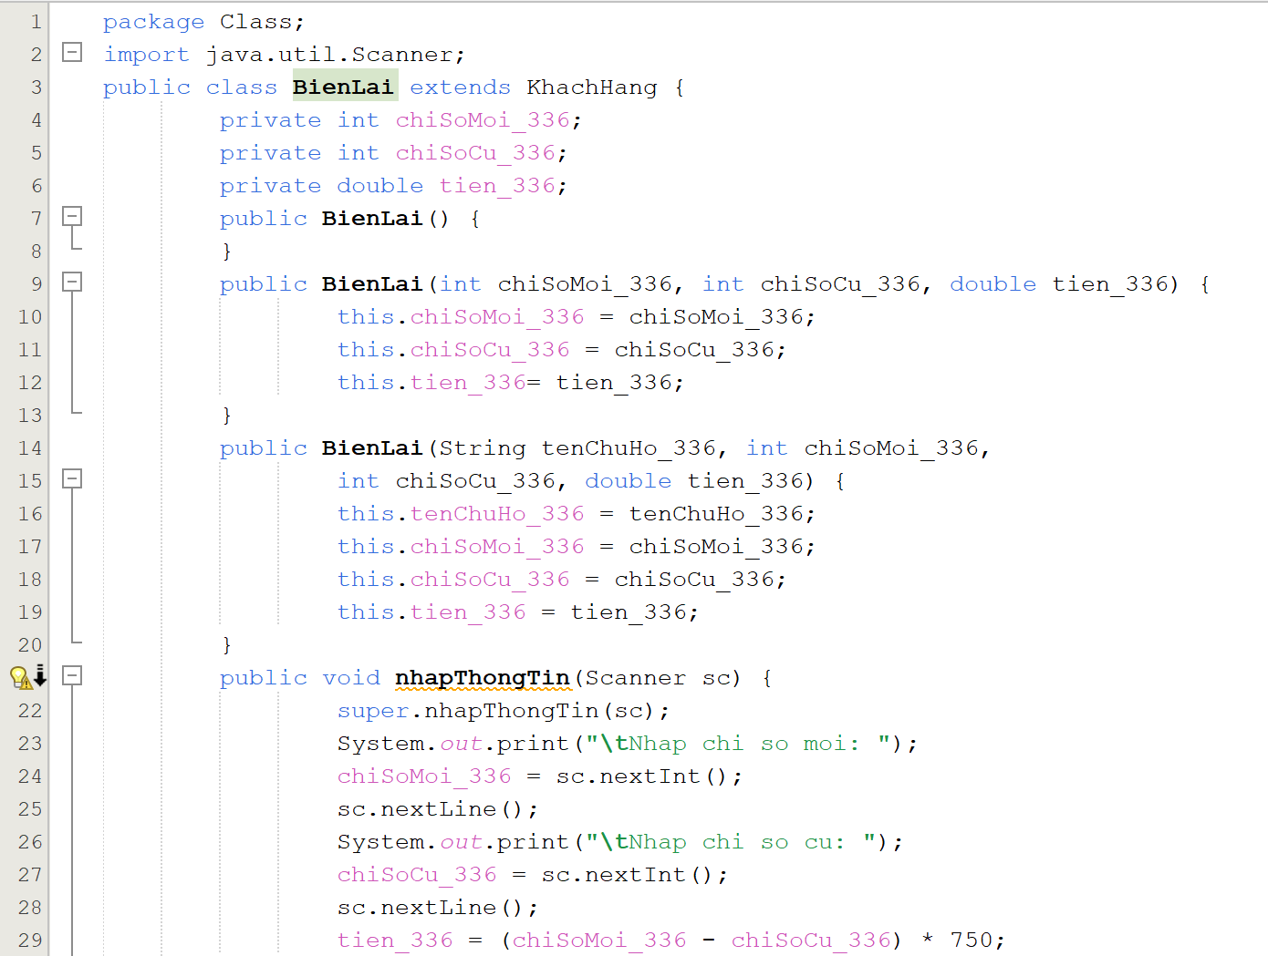

### Lớp QuanLy

### Lớp TestClass

## Kết quả

